Geometry: Unit 9, Lesson 8
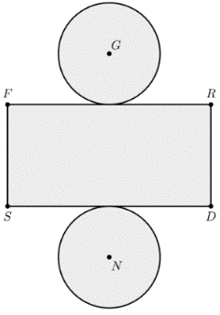
- A composite figure shown is made of two congruent circles with radius of $3$ centimeters $(cm)$, $FS=6 cm$, and $FR=12 cm$. What is the area of the composite figure?

$$128.52 cm^{2}$$

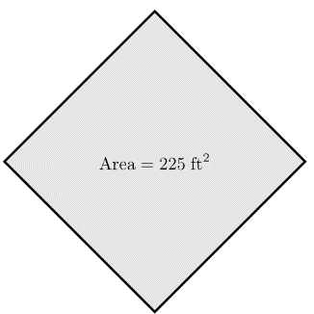
- A square with an area of $225$ feet squared is shown. What is the perimeter of the square?

$$60 feet$$
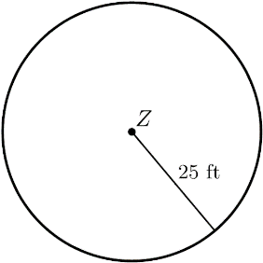
- Circle $Z$ is shown with a radius of $25$ feet $(ft.)$. What is the circumference of Circle $Z$?

$$50π ft$$

